LAPORAN PRAKTIKUM PENGOLAHAN CITRA DIGITAL
18. EDGE DETECTION



Disusun oleh :
Nama : Felix
NPM : 2327250059
Kelas : IF41

PROGRAM STUDI INFORMATIKA
FAKULTAS ILMU KOMPUTER DAN REKAYASA
UNIVERSITAS MULTI DATA PALEMBANG
2024

TUTORIAL : EDGE DETECTION

Goal
The goal of this tutorial is to learn how to implement edge detection and associated
techniques in MATLAB.

Objectives
- Learn how to use the IPT edge function.
- Explore the most popular first-derivative edge detectors: Roberts, Sobel, and Prewitt.
- Explore the Marr–Hildreth Laplacian of Gaussian edge detector.
- Explore the Canny edge detector.
- Learn how to implement edge detection with compass masks (Kirsch and Robinson).

What You Will Need
- lenna.tif
- mandrill.tif

Procedure
First-order edge detection methods, such as Prewitt and Sobel, are defined as convolution kernels. As we have seen in previous tutorials, convolution can be executed in MATLAB using the imfilter function. Although we could use this function to implement edge detection, we would be required to perform additional tasks, such as convolving the image twice (once for horizontal edges, and another for vertical ones) and adding the absolute values of these results to yield the final image. In practice, this image might also then be thresholded to produce a binary image where white pixels would represent edges. The function edge will do all this for us and will even determine a threshold value if we choose not to specify one.

Edge Detection Using the Prewitt Operator
- Load and display the test image.
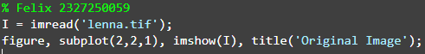
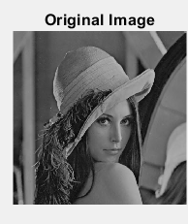

- Extract the edges in the image using the Prewitt operator.
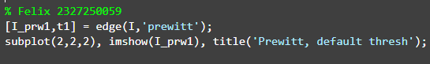
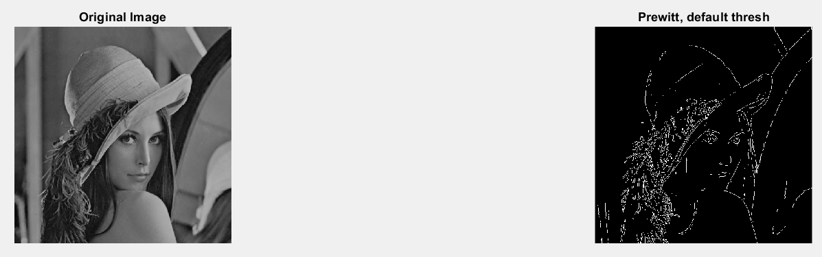

Question 1 What does the t1 variable represent?
Variabel t1 merepresentasikan nilai ambang yang digunakan oleh fungsi edge untuk memisahkan piksel tepi dan non-tepi. Nilai ini secara otomatis dihitung oleh MATLAB jika kita tidak memberikan nilai ambang secara manual.

Edge detection methods are often compared by their ability to detect edges in noisy images. Let us perform the Prewitt operator on the Lenna image with additive Gaussian noise.

- Add noise to the test image and extract its edges.
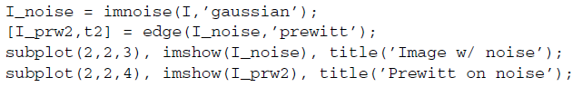
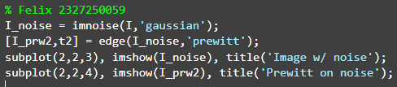
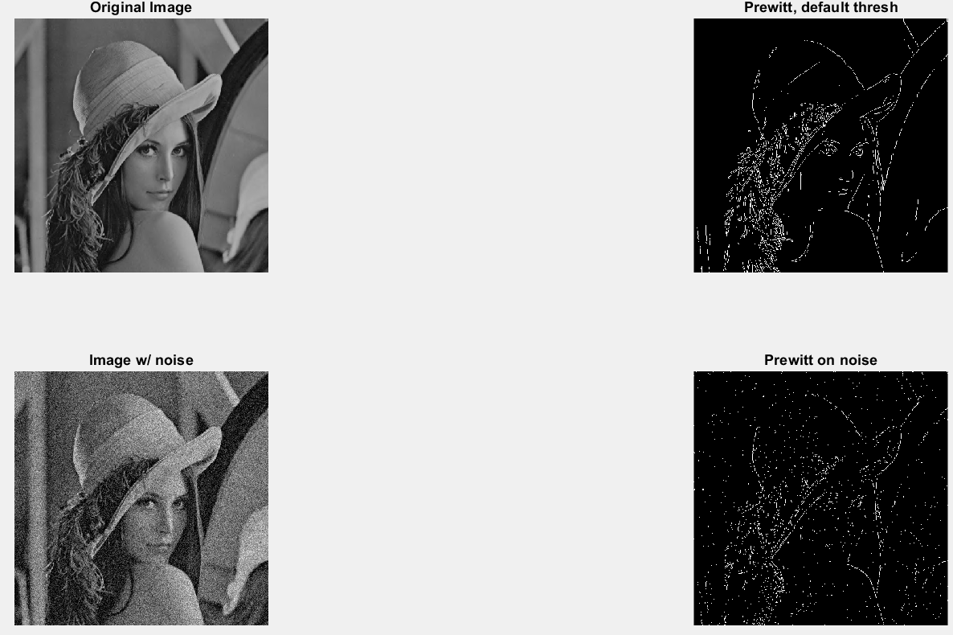

Question 2 How did the Prewitt edge detector perform in the presence of noise (compared to no noise)?
Kinerja detektor Prewitt memburuk saat ada noise, karena mendeteksi banyak tepi palsu akibat perubahan intensitas acak dari noise.

Question 3 Did MATLAB use a different threshold value for the noisy image?
Tidak selalu sama, karena kita tidak menambahkan nilai ambang, sehingga matlab manambahkannya secara otomatis.

Question 4 Try using different threshold values. Do these different values affect the operator’s response to noise? How does the threshold value affect the edges of the object?
Ya, nilai ambang batas sangat mempengaruhi hasil terhadap noise.
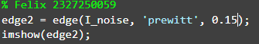
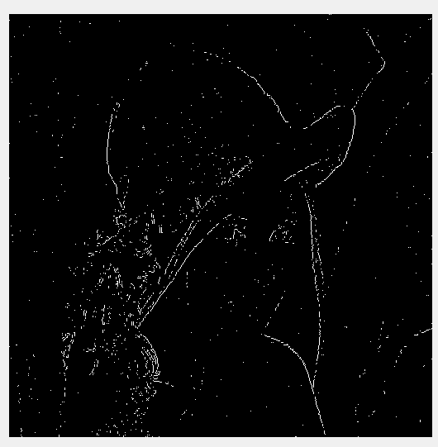

Edge Detection Using the Sobel Operator
- Extract the edges from the test image using the Sobel edge detector.
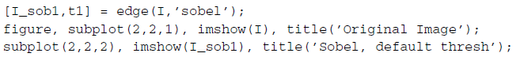
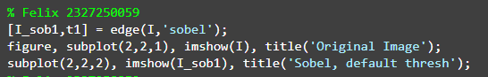
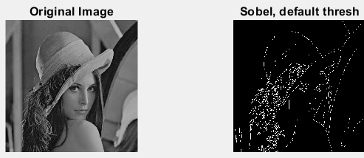

- Extract the edges from the test image with Gaussian noise using the Sobel edge detector.
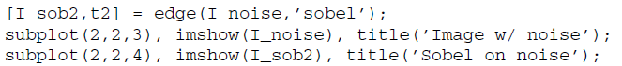
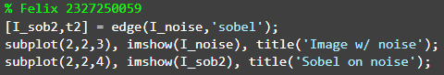
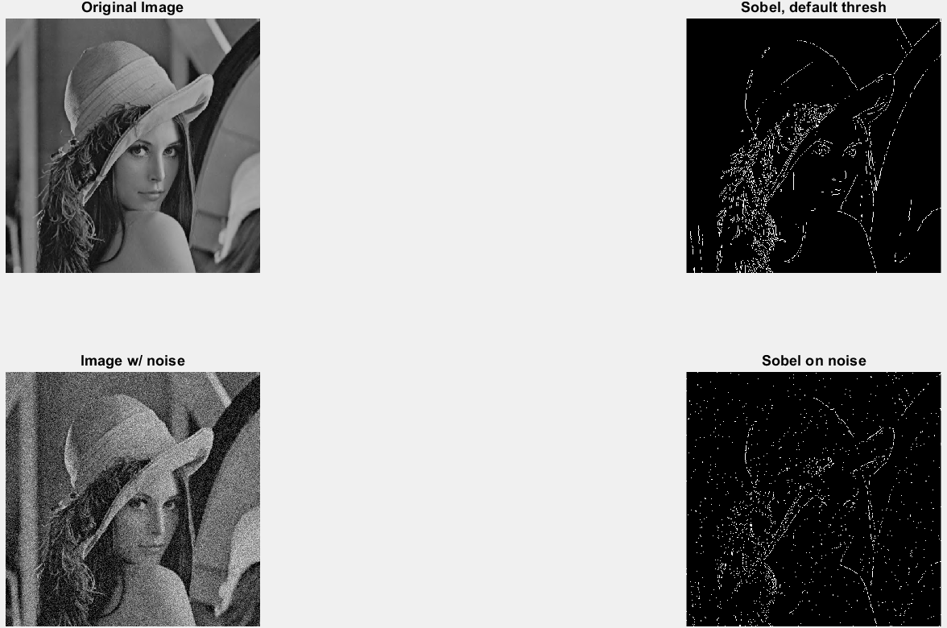

Question 5 How does the Sobel operator compare with the Prewitt operator with and without noise?
Operator Sobel dan Prewitt sama-sama efektif mendeteksi tepi pada gambar asli, tapi Sobel menghasilkan tepi yang lebih halus. Saat gambar diberi noise, Sobel lebih tahan terhadap gangguan noise dan menghasilkan deteksi tepi yang lebih bersih dibanding Prewitt, yang cenderung mendeteksi noise sebagai tepi palsu. Jadi, Sobel lebih cocok untuk gambar berisik.

Another feature of the edge function is ’thinning’, which reduces the thickness
of the detected edges. Although this feature is turned on by default, it can be turned off, which results in faster edge detection.

- Extract the edges from the test image with the Sobel operator with no thinning.
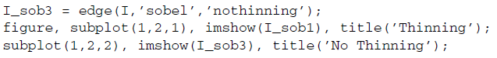
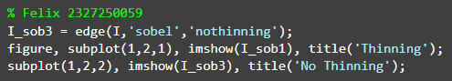
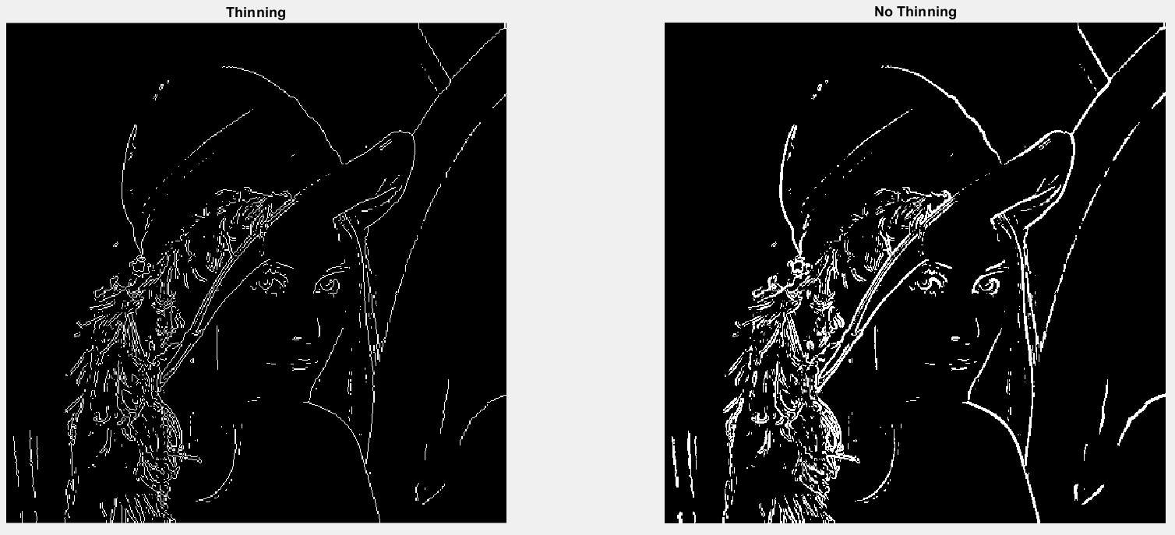

As you already know, the Sobel operator actually performs two convolutions (horizontal and vertical). These individual images can be obtained by using additional output parameters.

- Display the horizontal and vertical convolution results from the Sobel operator.
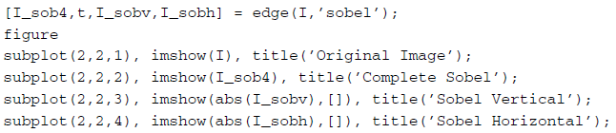
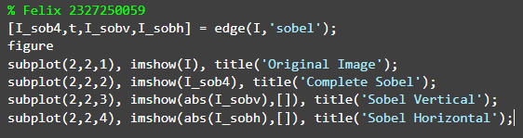
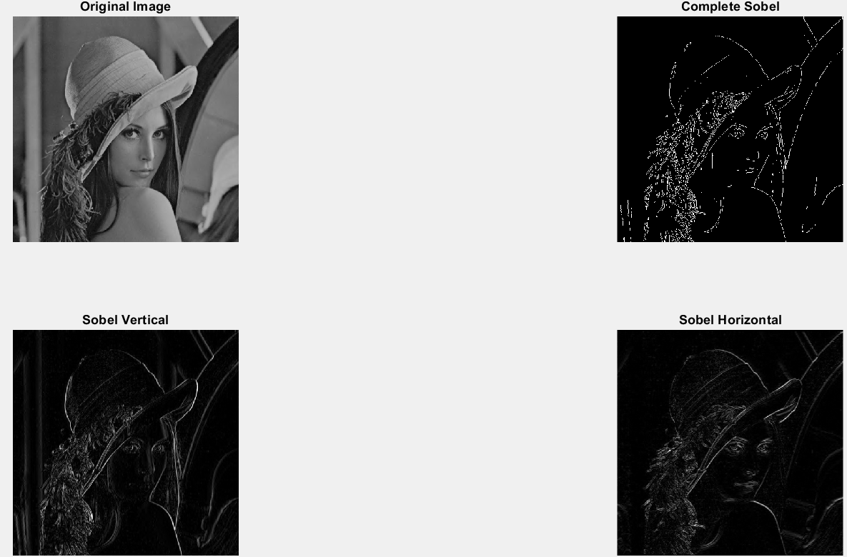

Question 6 Why do we display the absolute value of the vertical and horizontal images? Hint: Inspect the minimum and maximum values of these images.
Untuk melihat perubahan intensitas dan tepi-tepi yang dominan di arah vertical, dan melihat perubahan intensitas dan tepi-tepi yang dominan di arah horizontal.

Question 7 Change the code in step 7 to display thresholded (binarized), not
thinned, versions of all images.
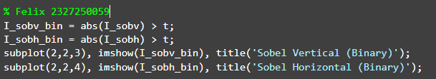
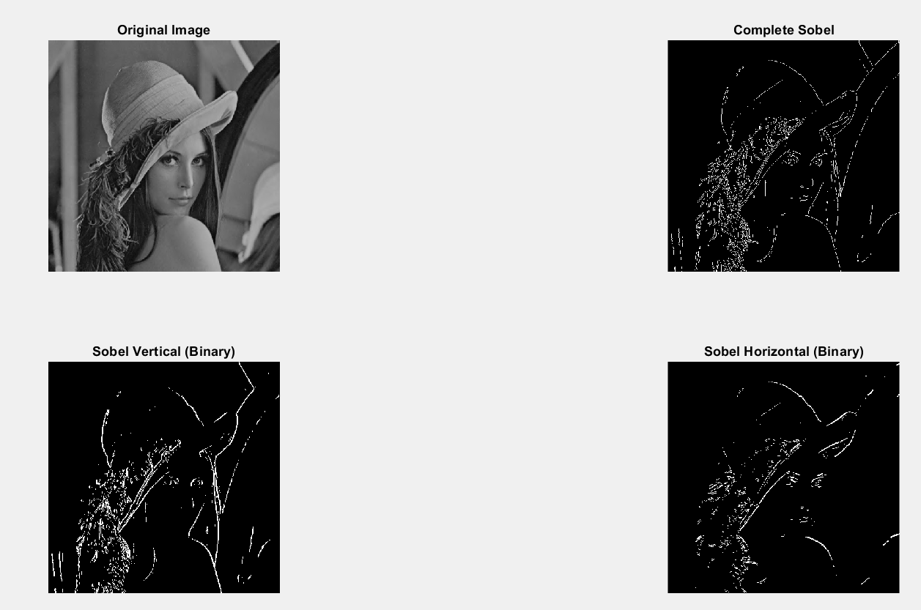

As you may have noticed, the edge function returns the vertical and horizontal images before any thresholding takes place.

Edge Detection with the Roberts Operator
Similar options are available with the edge function when the Roberts operator is used.

- Extract the edges from the original image using the Roberts operator.
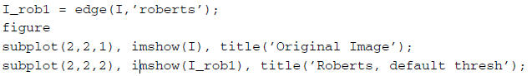
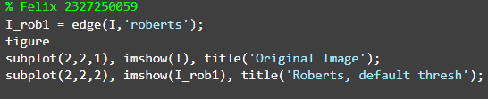
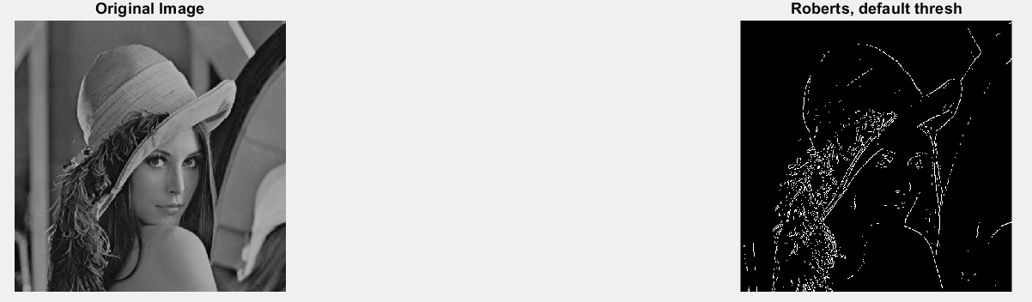

- Apply the Roberts operator to a noisy image.
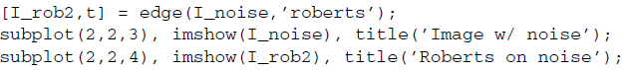
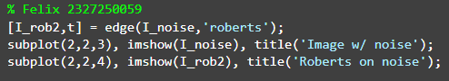
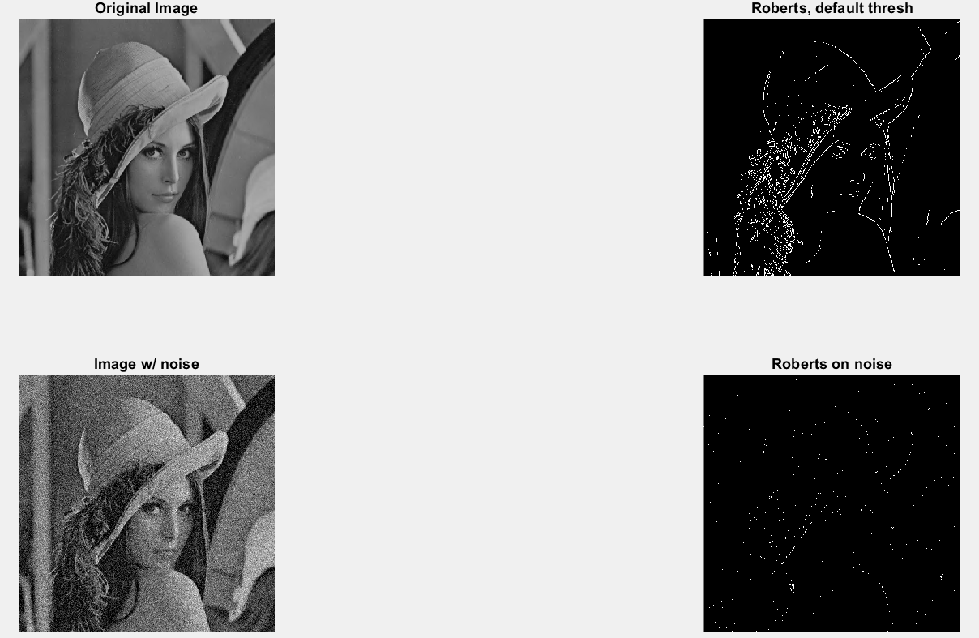

Question 8 Compare the Roberts operator with the Sobel and Prewitt operators. How does it hold up to noise?
Roberts:
- Sangat sensitif terhadap noise.
- Karena menggunakan kernel kecil 2x2 tanpa smoothing, bahkan noise kecil bisa dianggap sebagai tepi.
- Cocok untuk citra yang bersih dan beresolusi rendah.
Prewitt:
- Lebih stabil terhadap noise dibanding Roberts karena menggunakan 3x3 kernel.
- Kernel Prewitt melakukan perataan ringan (average filter) secara tidak langsung.
- Masih bisa terpengaruh noise, terutama noise acak seperti Gaussian.
Sobel:
- Paling tahan terhadap noise.
- Kernel Sobel menekankan bobot di tengah (misalnya: 2 di tengah kolom/row), yang bertindak seperti smoothing tambahan.
- Lebih baik dalam menyeimbangkan deteksi tepi dan penekanan noise.

Question 9 If we were to adjust the threshold, would we get better results when filtering the noisy image?
Ya, menyesuaikan ambang batas dapat membantu memperoleh hasil yang lebih baik dalam menyaring gambar yang berisik, tetapi ada batas efektivitasnya tergantung pada jenis noise dan metode deteksi tepi yang digunakan.

Question 10 Suggest a method to reduce the noise in the image before performing edge detection.
Menggunakan median filter, mean filter, dll.

Edge Detection with the Laplacian of a Gaussian Operator
The LoG edge detector can be implemented with the edge function as well. Let us see its results.

- Extract the edges from the original image using the LoG edge detector.
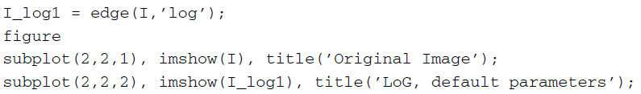
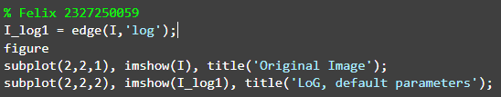
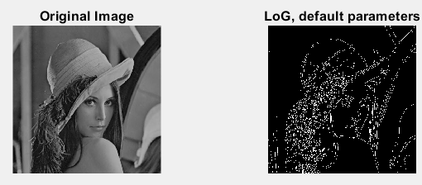

- Apply the LoG edge detector to the noisy image.
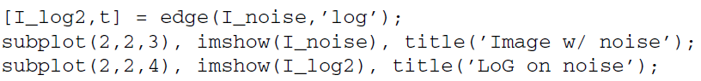
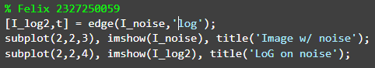
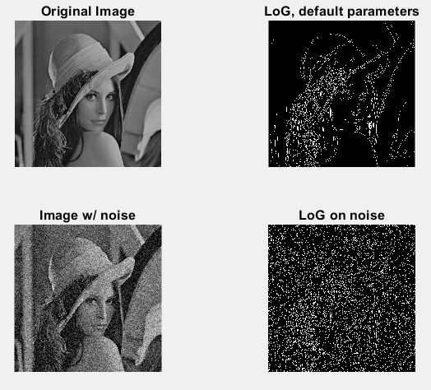

Question 11 By default, the LoG edge detector uses a value of 2 for σ (the standard deviation of the filter). What happens when we increase this value?
Gunakan sigma kecil jika ingin mendeteksi detail halus.
Gunakan sigma besar jika ingin meminimalkan noise dan hanya fokus pada tepi besar.

Edge Detection with the Canny Operator
- Extract the edges from the original image using the Canny edge detector.
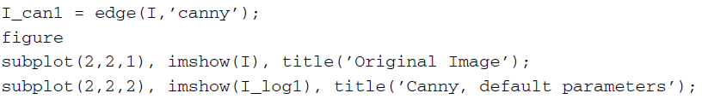
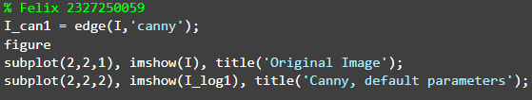
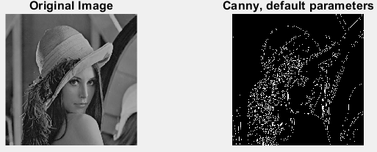

- Apply the filter to the noisy image.
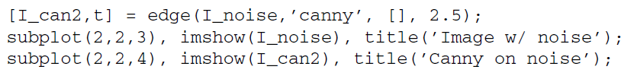

As you know, the Canny detector first applies a Gaussian smoothing function to the image, followed by edge enhancement. To achieve better results on the noisy image, we can increase the size of the Gaussian smoothing filter through the sigma parameter.

- Apply the Canny detector on the noisy image where sigma = 2.
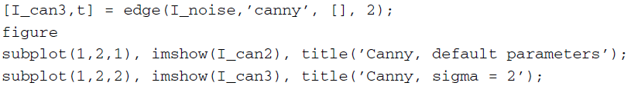
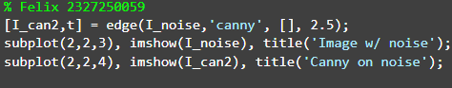
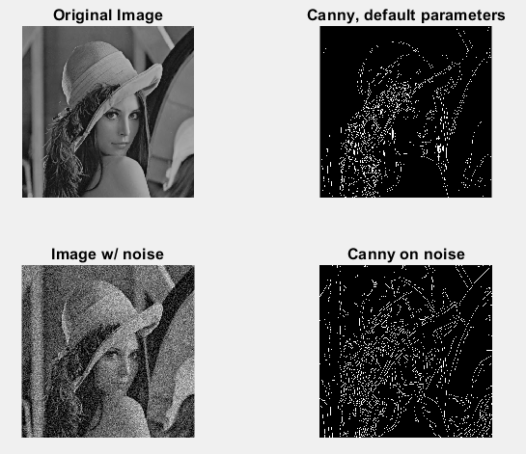

Question 12 Does increasing the value of sigma give us better results when using the Canny detector on a noisy image?
Ya, meningkatkan nilai sigma pada detektor Canny dapat memberikan hasil yang lebih baik saat digunakan pada gambar yang noise.

Another parameter of the Canny detector is the threshold value, which affects the sensitivity of the detector.

- Close any open figures and clear all workspace variables.
- Load the mandrill image and perform the Canny edge detector with default parameters.
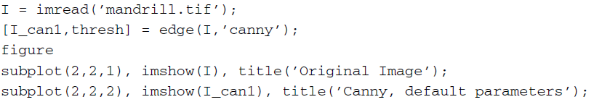
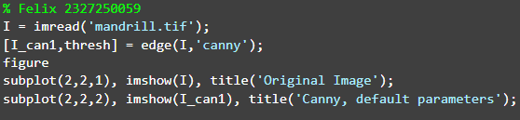
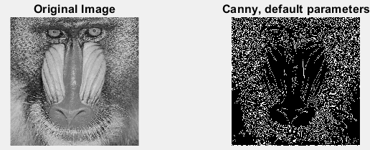

- Inspect the contents of variable thresh.
- Use a threshold value higher than the one in variable thresh.
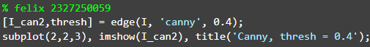
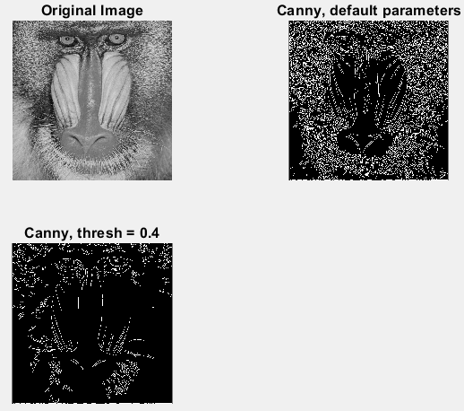

- Use a threshold value lower than the one in variable thresh.
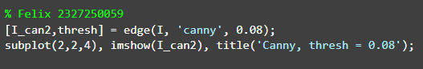
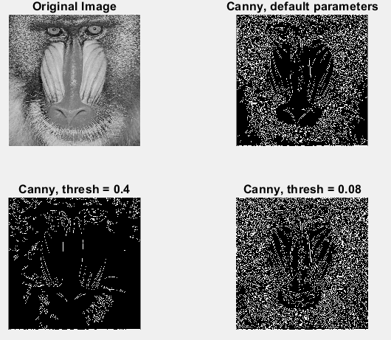

Question 13 How does the sensitivity of the Canny edge detector change when the threshold value is increased?
semakin di tingkatkan maka semakin sedikit detail kecil yang di dapat.

Edge Detection with the Kirsch Operator
The remaining edge detection techniques discussed in this tutorial are not included
in the current implementation of the edge function, so we must implement them as
they are defined. We will begin with the Kirsch operator.

- Close any open figures and clear all workspace variables.
- Load the mandrill image and convert it to double format.
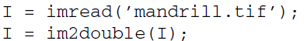
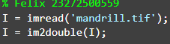

Previously, when we were using the edge function, we did not need to convert the image to class double because the function took care of this for us automatically. Since now we are implementing the remaining edge detectors on our own, we must perform the class conversion to properly handle negative values (preventing unwanted truncation).

Next we will define the eight Kirsch masks. For ease of implementation, we will store all eight masks in a 3 × 3 × 8 matrix. Figure 18.1 illustrates this storage format.

- Create the Kirsch masks and store them in a preallocated matrix.
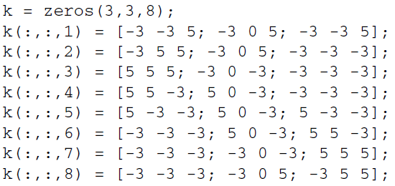
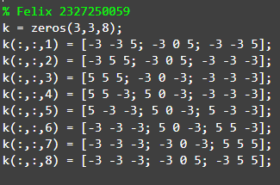

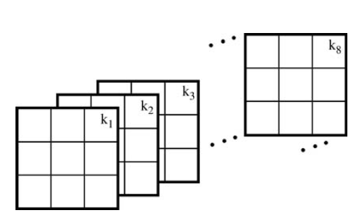
FIGURE 18.1 Kirsch masks stored in a 3 × 3 × 8 matrix.

Next we must convolve each mask on the image, generating eight images.We will store these images in a three-dimensional matrix just as we did for the masks. Because all the masks are stored in one matrix, we can use a for loop to perform all eight convolutions with less lines of code.

- Convolve each mask with the image using a for loop.
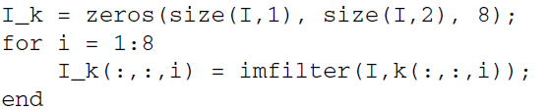
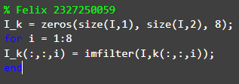

- Display the resulting images.
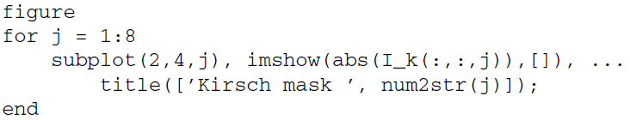
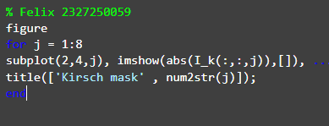
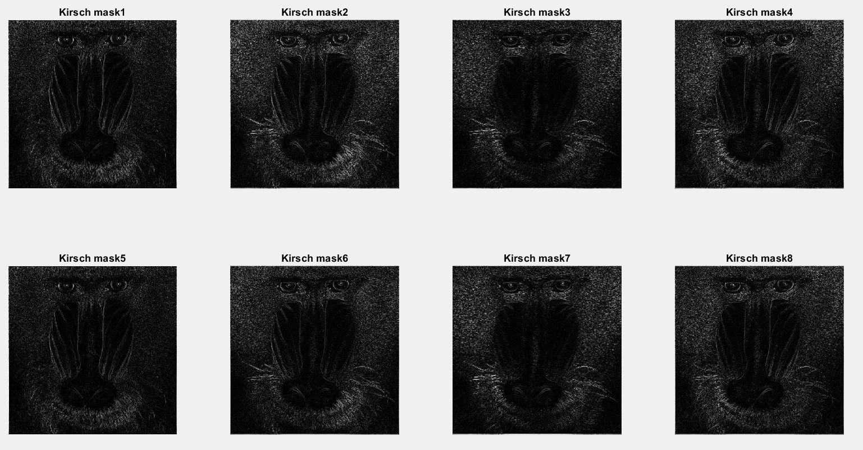

Question 14 Why are we required to display the absolute value of each mask? Hint: Inspect the minimum and maximum values.
Hasil konvolusi bisa mengandung nilai negatif maupun positif, tergantung arah dan intensitas perubahan citra (gradien). Namun, gambar hanya bisa menampilkan nilai dalam rentang positif (biasanya 0–255 atau 0–1). Jika tidak diubah menjadi nilai absolut, tepi dengan nilai negatif tidak akan tampak (akan terlihat gelap atau bahkan tidak muncul).

Question 15 How did we dynamically display the mask number when displaying all eight images?
Dengan for pada kode sebelumnya yang dengan menyesuaikan ukuran 1 per satu sampai 8x untuk cara membuat filternya, lalu tampilkan 1 persartu dengan for juga.

Next we must find the maximum value of all the images for each pixel. Again,
because they are all stored in one matrix, we can do this in one line of code.

- Find the maximum values.
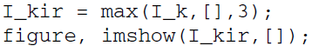
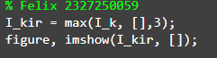
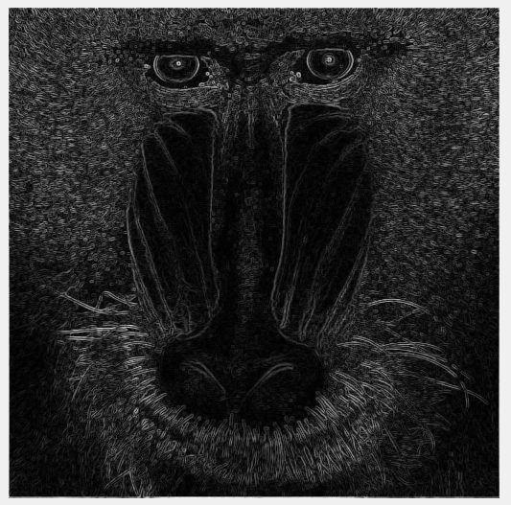

Question 16 When calculating the maximum values, what does the last parameter in the max function call mean?
Fungsi parameter pada akhir kode Adalah untuk menunjukkan bahwa nilai maksimum di hitung dari dimensi ke-3.

Question 17 Why are we required to scale the image when displaying it?
karena bila menggunakan min detai dari gambar hilang sehingga gambar sulit di pahami.

In the previous step we scaled the result for display purposes. If we wish to threshold the image (as we did with all previous edge detectors), we must first scale the image so that its values are within the range [0, 255] as well as convert to class uint8. To do so, we can create a linear transformation function that maps all current values to values within the range we want.

- Create a transformation function to map the image to the grayscale range and perform the transformation.
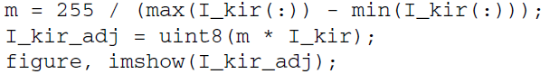

Question 18 Why is it not necessary to scale this image (I_kir_adj) when displaying it?
karena sudah di umbah ke dalam uint8 lalu dikali m.

Question 19 Make a copy of the mandrill image and add Gaussian noise to it. Then perform the Kirsch edge detector on it. Comment on its performance when noise is present.
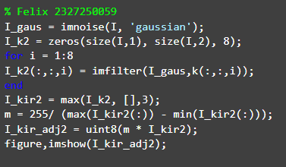
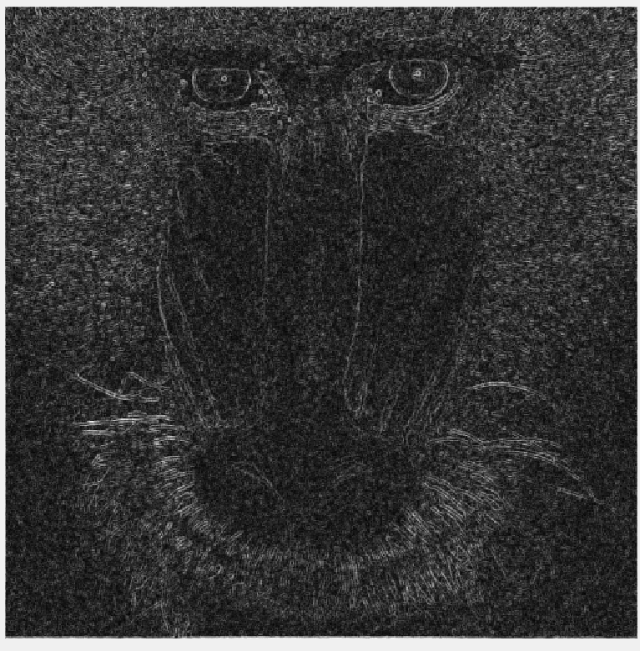

Edge Detection with the Robinson Operator
The Robinson edge detector can be implemented in the same manner as the Kirsch detector. The only difference is the masks.

- Generate the Robinson masks.
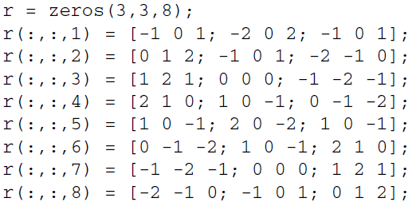
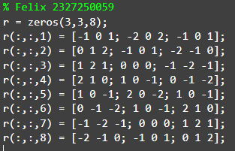

- Filter the image with the eight Robinson masks and display the output.
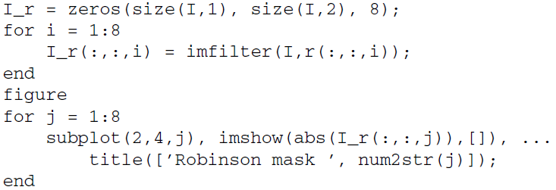
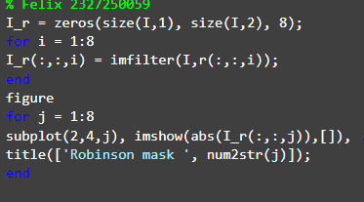
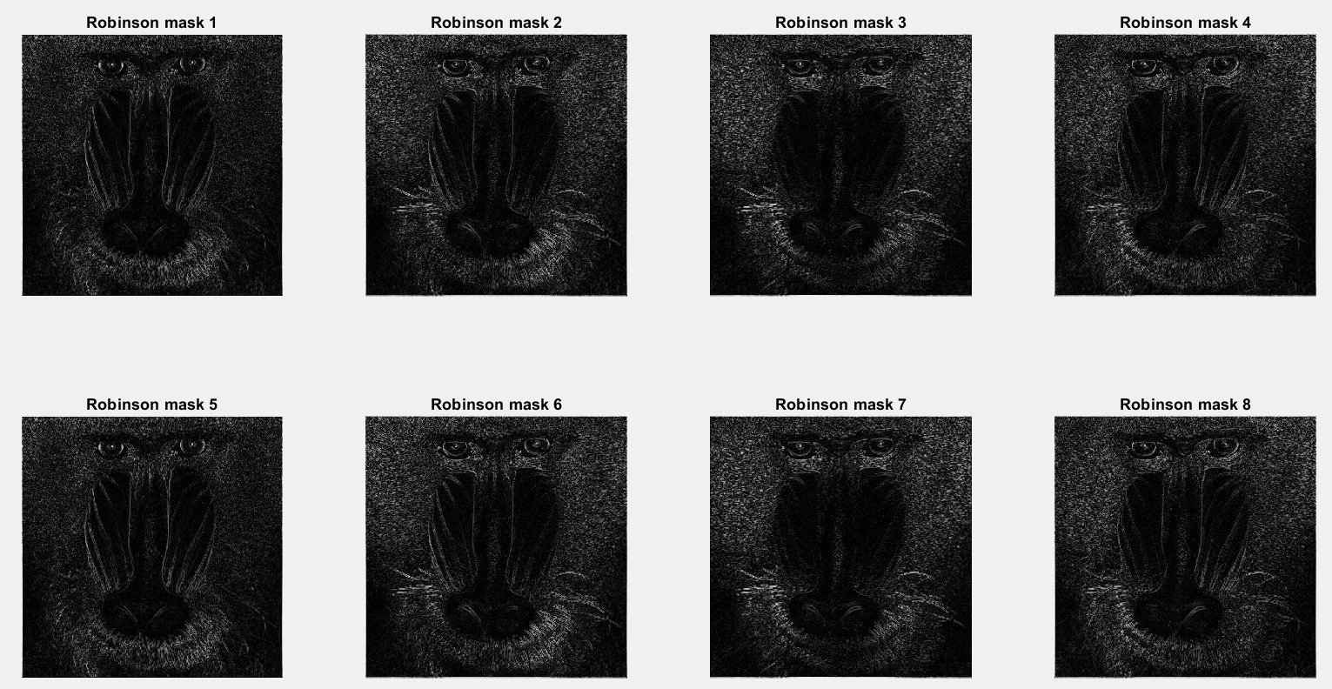

- Calculate the max of all eight images and display the result.
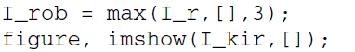
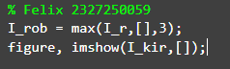
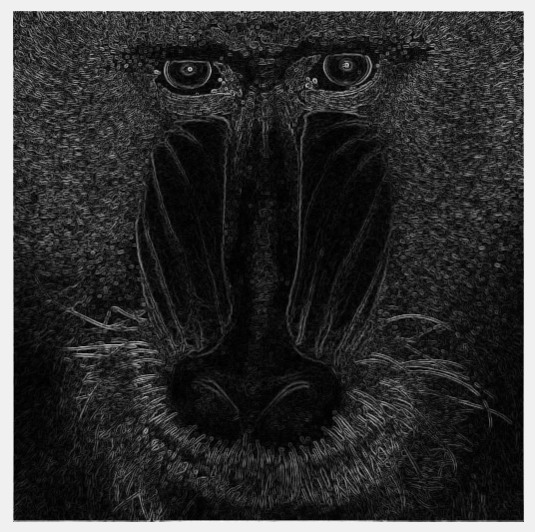

Question 20 How does the Robinson edge detector compare with the Kirsch detector?
Detektor Kirsch menghasilkan tepi yang lebih tajam dan kontras dibandingkan dengan detektor Robinson, yang cenderung memberikan hasil tepi yang lebih halus dan lembut. Hal ini disebabkan oleh bobot kernel Kirsch yang lebih besar dan ekstrem dibandingkan kernel Robinson yang lebih seimbang.

